**ASSIGNMENT-2**

1. Converting Roman Numbers to integers. 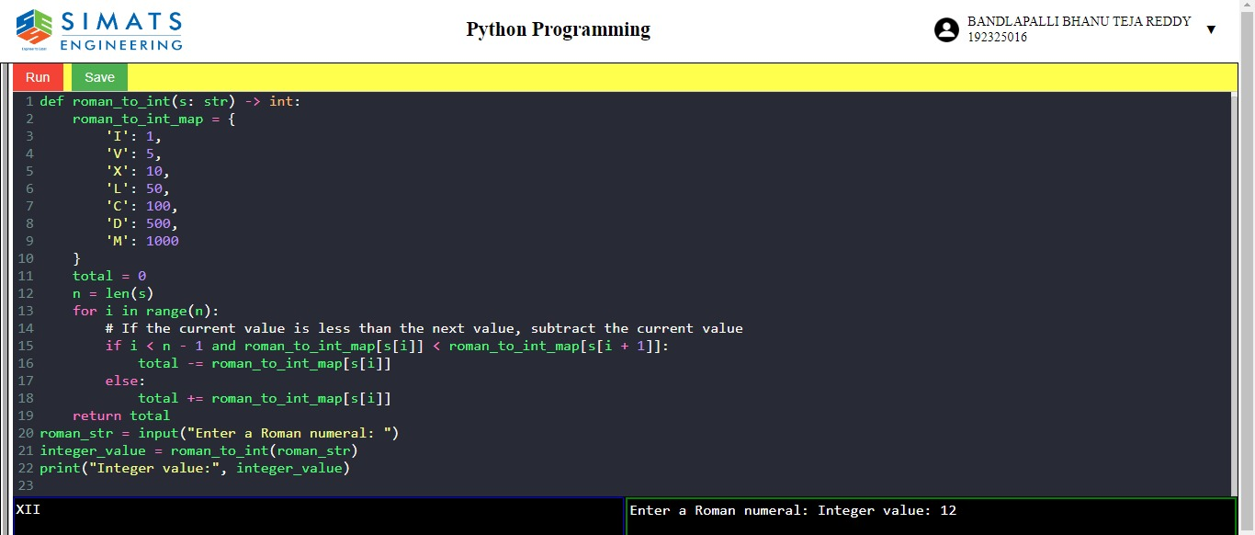

2.LARGEST COMMON PREFIX

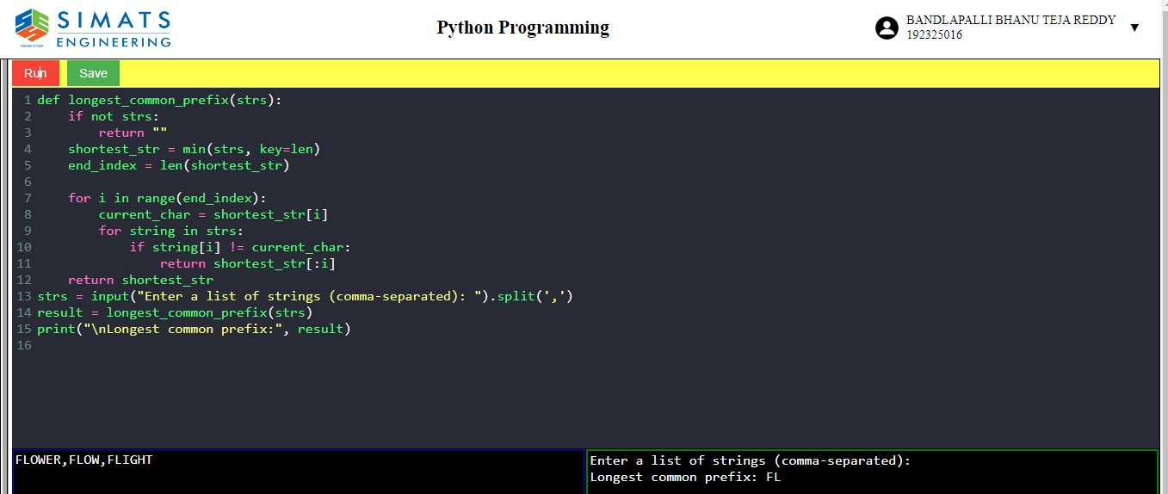

3.ROOT TO LEAF PATH WITH TARGET SUM.

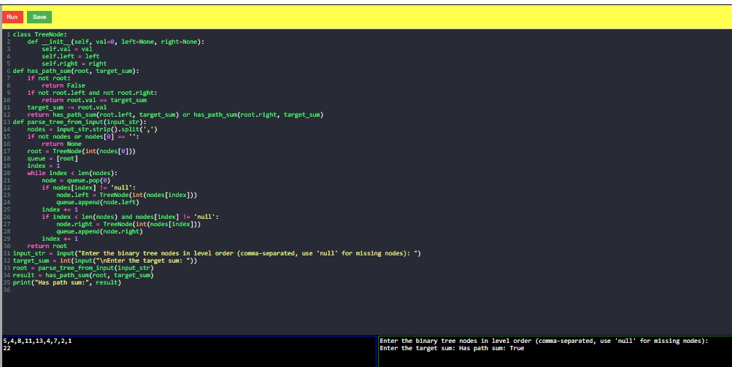

4.BINARY TREE TRAVERSAL.

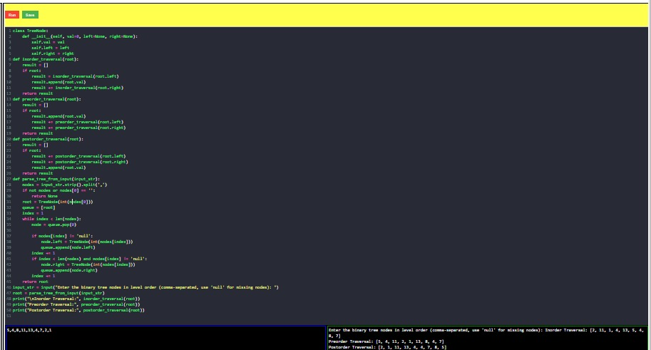

5.BIT REVERSING

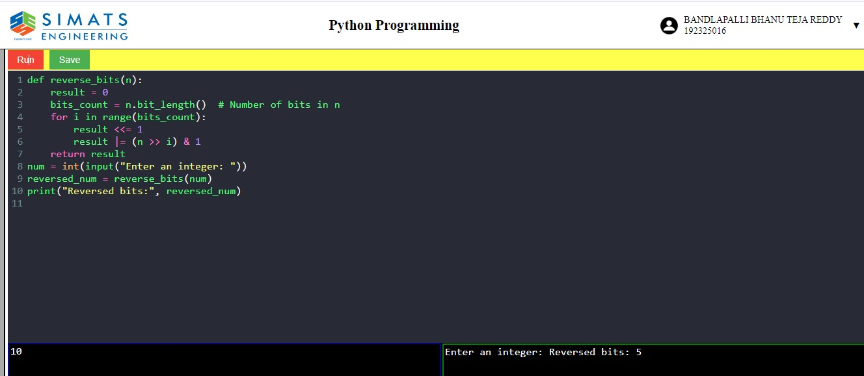

6.CONVERT SORTED ARRAY TO BINARY SEARCH TREE.

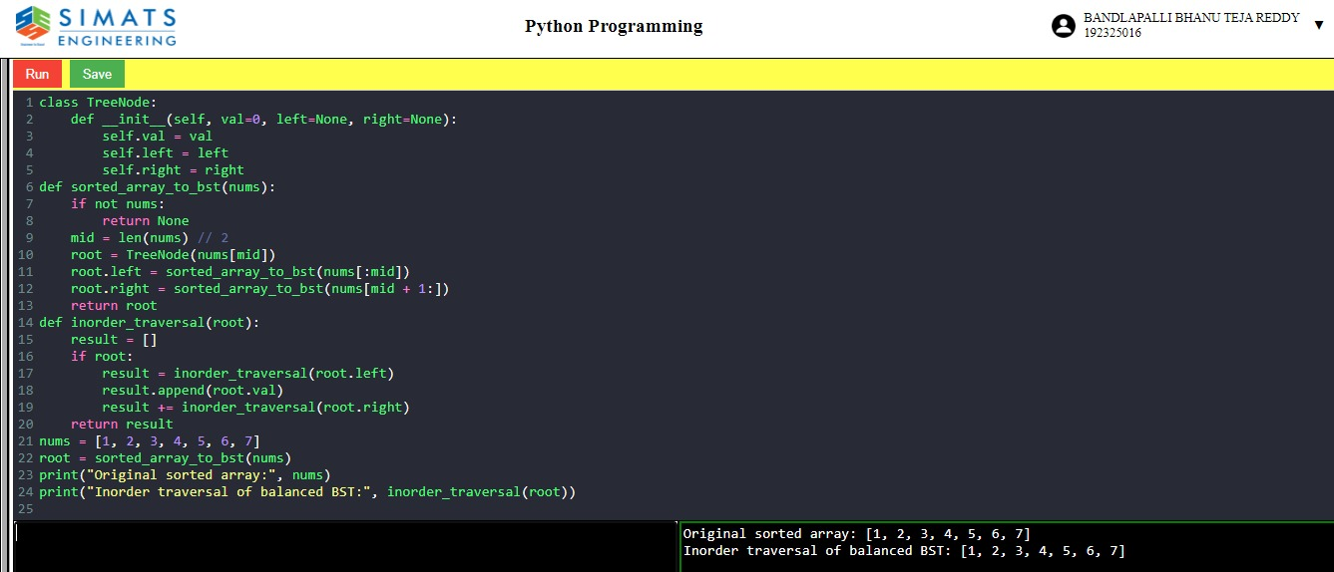

7.FIND THE FIVEN BINARY TREE IS HEIGHT BALANCED OR NOT.

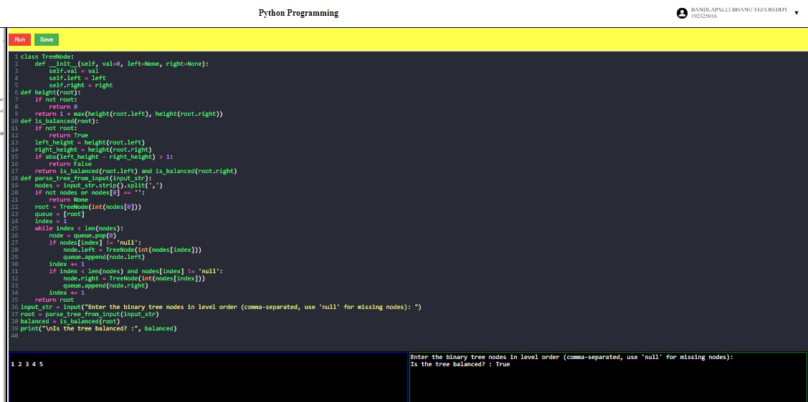

8.FIND THE NUMBER OF DISTINCT WAYS TO CLIMB STAIRCASE.

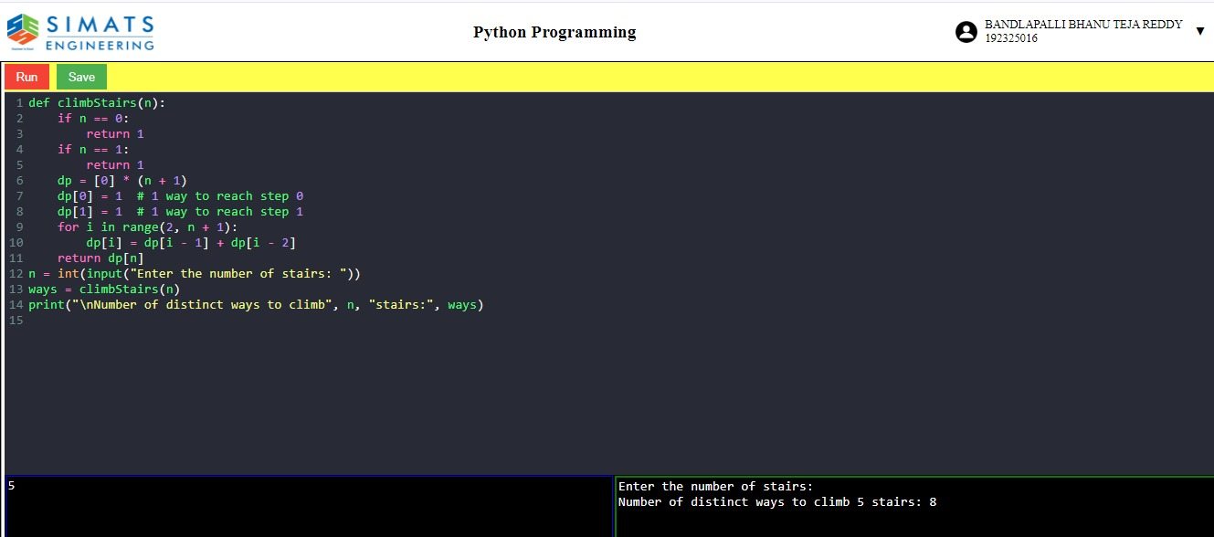

9.BEST TIME TO BUY AND SELL STOCK.

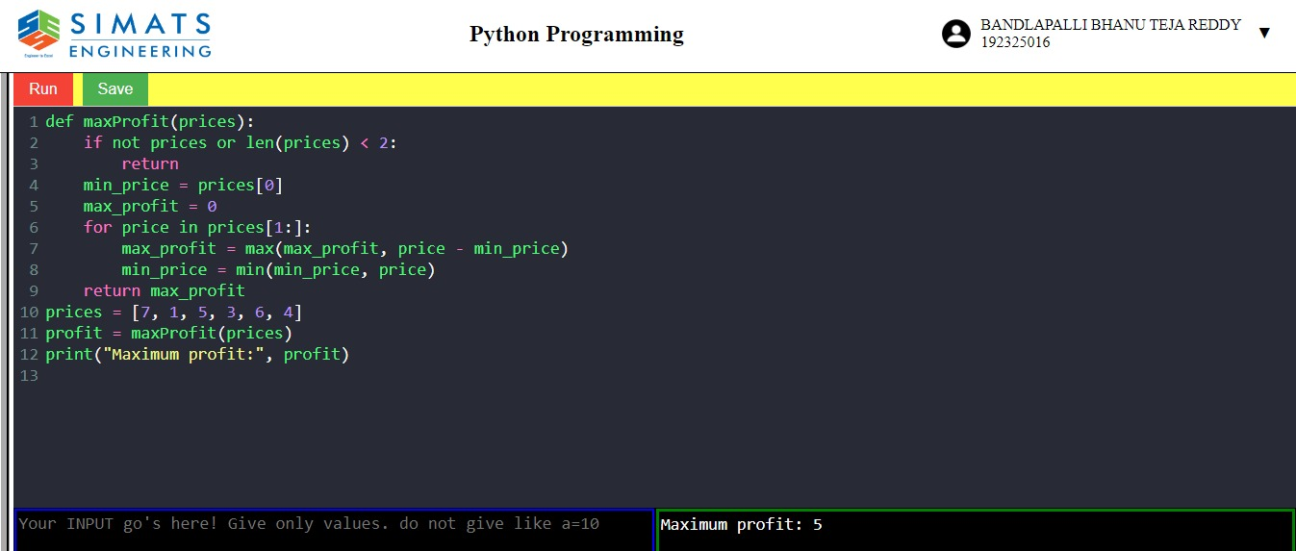

10.ADD BINARY NUMBERS AND GIVE THE OUTPUT IN BINARY FORM. 